Chapter 5, Solution 20.

−
+
2 kΩ
+
v_{o}
−
4 kΩ
4 kΩ
9 V

+
−
8 kΩ
a
b
v_{s}

+
−

At node a,

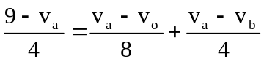 18 = 5v_{a} – v_{o} – 2v_{b} (1)

At node b,

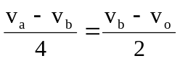 v_{a} = 3v_{b} – 2v_{o} (2)

But v_{b} = v_{s} = 2 V; (2) becomes v_{a} = 6 –2v_{o} and (1) becomes

–18 = 30–10v_{o} – v_{o} – 4 v_{o} = –44/(–11) = 4 V.

